**The cities of dreams**

**Consultant:** Petar Geogriev

**Equip:**

1. Plamen Kostov, 9.g, [PKKostov18@codingburgas.bg](mailto:PKKostov18@codingburgas.bg)
2. Ilian Yanev, 9.g, [IMYanev18@codingburgas.bg](mailto:Imyanev18@codingburgas.bg)
3. Kristian Lalev, 9.g, [KALalev18@codingburgas.bg](mailto:KALalev18@codingburgas.bg)
4. Kiril Dimov, 9.g, [KHDimov18@codingburgas.bg](mailto:KHDimov18@codingburgas.bg)
5. Kristiyan Karchev, 9.g, [KKKarchev18@codingburgas.bg](mailto:KKKarchev18@codingburgas.bg)
6. Hristo Hristov, 9.b, [HSHristov18@codingburgas.bg](mailto:HSHristov18@codingburgas.bg)

**Why we chose this topic?**

* We chose this topic because we wanted to do something about this from the beginning of the projects.
* We were interested in it.

**Realization:**

* HTML and CSS – Plamen Kostov, Ilian Yanev and Hristo Hristov
* Presentation and Documentation – Kristian Lalev, Kiril Dimov and Kristiyan Karchev
* Giving ideas – All of the team gave ideas

**What is out project about?**

* Our project is about the cities of our dreams which have lots of landmarks or which are very big. All of the cities are very beautiful. We are also helping you with that when are you going to spend your vacantion.

**Introduction:** Everybody has its own dream city. In our site you can find some information about our dream cities. We arranged them as we decided.

**What is the purpose of the project?**

* To help you with the travelling, when do you want to travel and what to see in some of the best cities.

**Diagram of the site:**

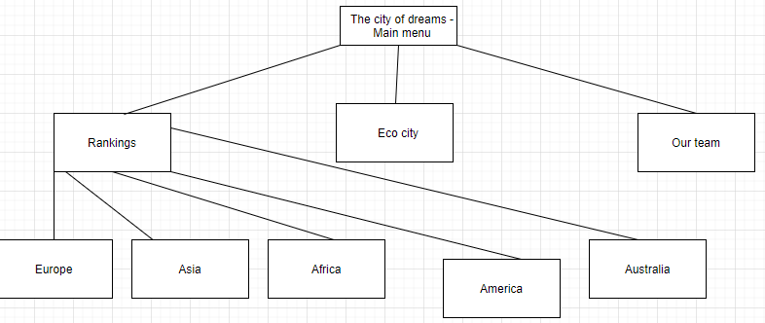

**That is how the site looks like:**

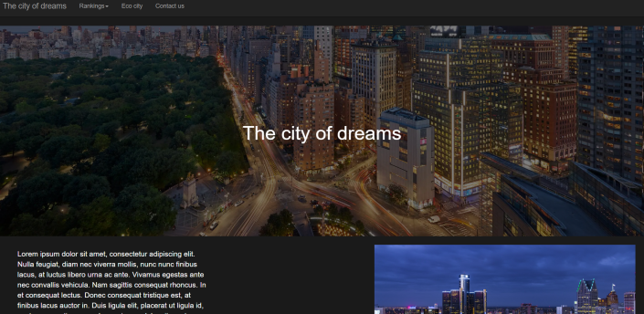

**Planning:** The only thing that we don’t planned was the time for work on the project.

**Analytics:** We browsed other related sites. The idea of the cities of dreams is well-described there. In our site, we selected some of the most dreamed cities and in our opinion, we arranged it as these of them which we like the most to these which we like the least.

**Project complexity level:** We encountered difficulties with a lot of things, such as writing on markup languages HTML5 and CSS3 and designing everything.

**Conclusion:** Everybody is happy when they visit our site. And we are recommending some really good cities to spend your time there.